**SAVEETHA SCHOOL OF ENGINEERING (SIMATS)**

INSTITUTE OF MECHANICAL ENGINEERING

B.E./B.Tech UNIVERSITY LAB EXAMINATION

APRIL – 2022

**MEA0159 Engineering Graphics with Geometrical Tolerance**

1. To draw the Title Block with necessary texts and Projection Symbol using AutoCAD **(CO1)**

|  |  |  |
| --- | --- | --- |
| **S. No** | **Description** | **Marks** |
| 1 | Drawing | 5 |
| 2 | Dimension & Annotation | 5 |
| 3 | Layout | 5 |
| 4 | Printout | 5 |
|  | **Total** | 20 |

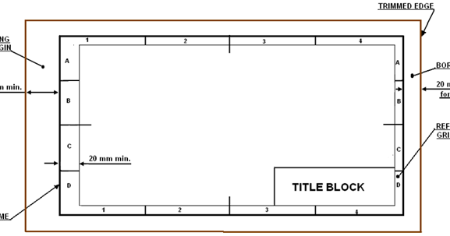

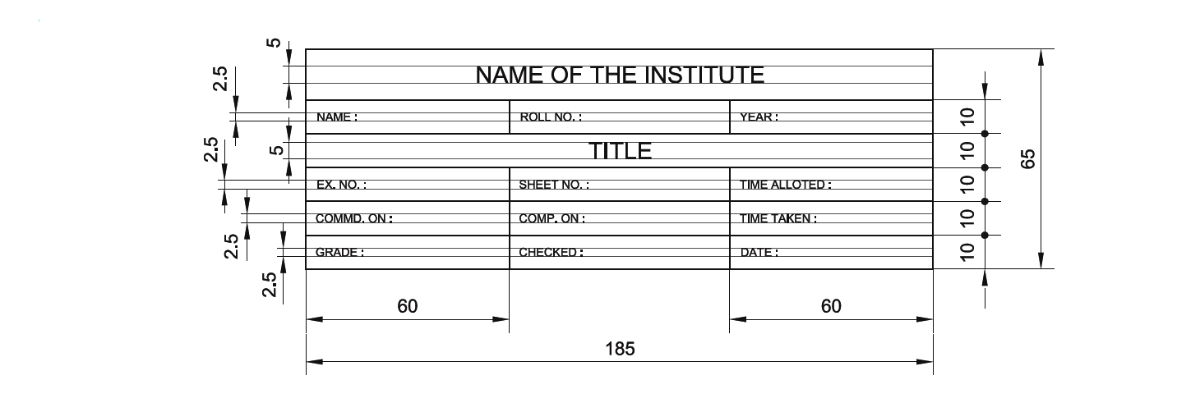

1. To create the basic geometrical shapes of given dimensions in AutoCAD **(CO1).**

|  |  |  |
| --- | --- | --- |
| **S. No** | **Description** | **Marks** |
| 1 | Drawing | 5 |
| 2 | Dimension & Annotation | 5 |
| 3 | Layout | 5 |
| 4 | Printout | 5 |
|  | **Total** | 20 |

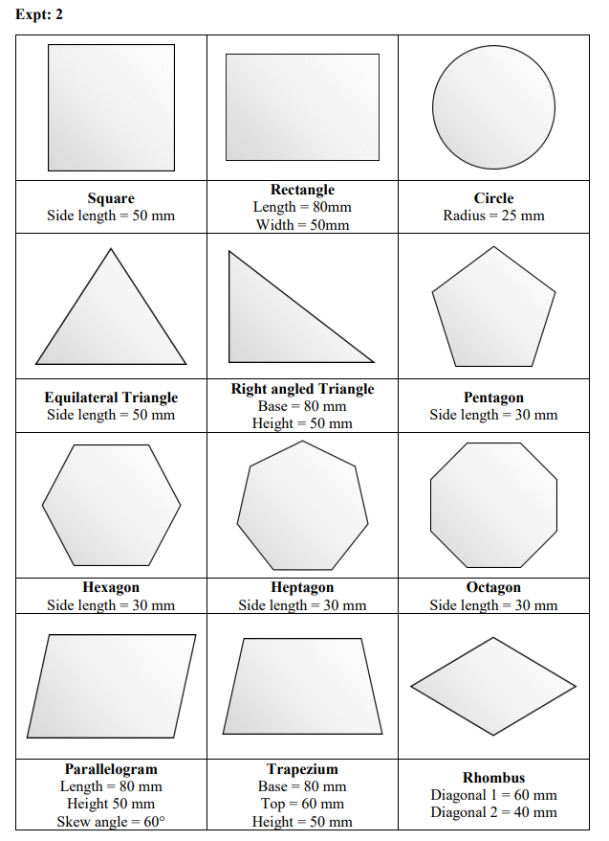

1. To create 2D models of the given multi-line figures in AutoCAD **(CO3).**

|  |  |  |
| --- | --- | --- |
| **S. No** | **Description** | **Marks** |
| 1 | Drawing | 5 |
| 2 | Dimension & Annotation | 5 |
| 3 | Layout | 5 |
| 4 | Printout | 5 |
|  | **Total** | 20 |

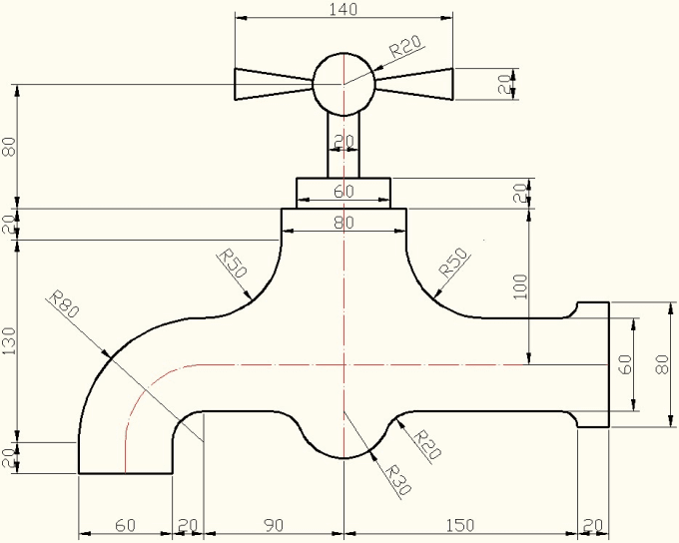

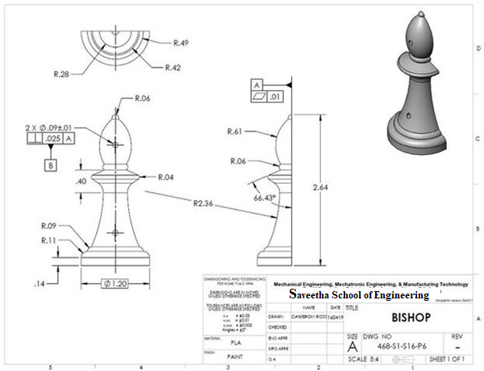

1. To construct the conic curves – ellipse, parabola, and hyperbola using the given specifications in AutoCAD **(CO2).**

|  |  |  |
| --- | --- | --- |
| **S. No** | **Description** | **Marks** |
| 1 | Drawing | 5 |
| 2 | Dimension & Annotation | 5 |
| 3 | Layout | 5 |
| 4 | Printout | 5 |
|  | **Total** | 20 |

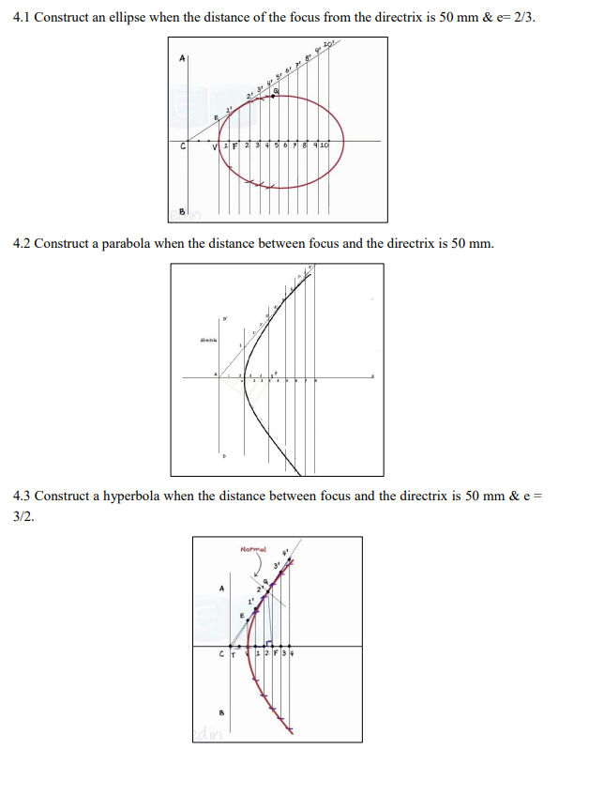

1. To construct the plan view of the given single storey residential building using AutoCAD. **(CO4)**

|  |  |  |
| --- | --- | --- |
| **S. No** | **Description** | **Marks** |
| 1 | Drawing | 5 |
| 2 | Dimension & Annotation | 5 |
| 3 | Layout | 5 |
| 4 | Printout | 5 |
|  | **Total** | 20 |

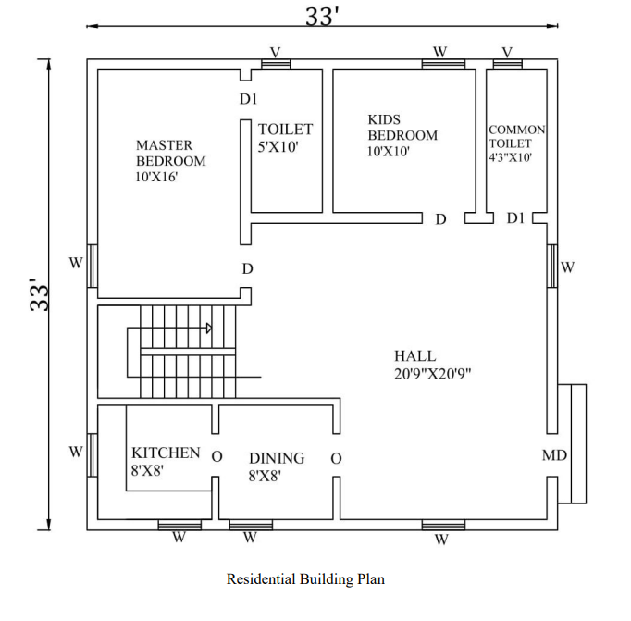

1. Drawing Orthographic Projections of Simple Solids **(CO2)**

|  |  |  |
| --- | --- | --- |
| **S. No** | **Description** | **Marks** |
| 1 | Drawing | 5 |
| 2 | Dimension & Annotation | 5 |
| 3 | Layout | 5 |
| 4 | Printout | 5 |
|  | **Total** | 20 |

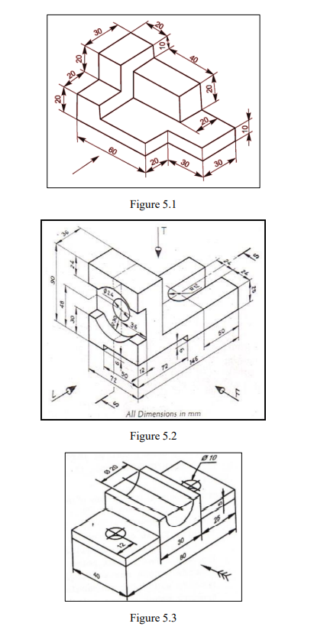

1. Draw the isometric projections of simple solids **(CO5)**

|  |  |  |
| --- | --- | --- |
| **S. No** | **Description** | **Marks** |
| 1 | Drawing | 5 |
| 2 | Dimension & Annotation | 5 |
| 3 | Layout | 5 |
| 4 | Printout | 5 |
|  | **Total** | 20 |

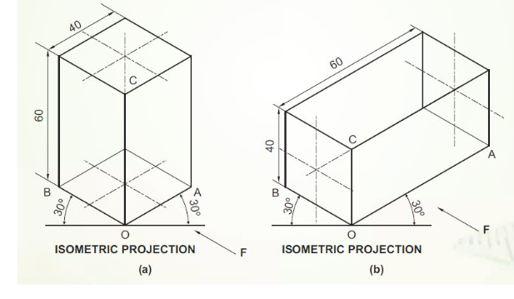

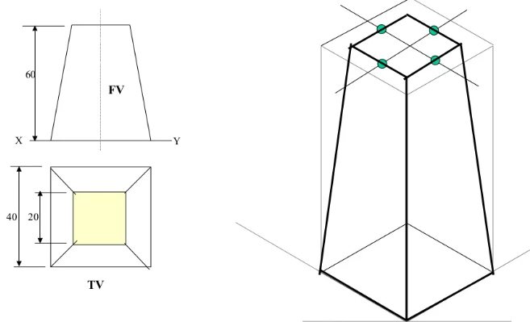

1. To construct the various sectional views of the given solid using the AutoCAD software**. (CO6)**

|  |  |  |
| --- | --- | --- |
| **S. No** | **Description** | **Marks** |
| 1 | Drawing | 5 |
| 2 | Dimension & Annotation | 5 |
| 3 | Layout | 5 |
| 4 | Printout | 5 |
|  | **Total** | 20 |

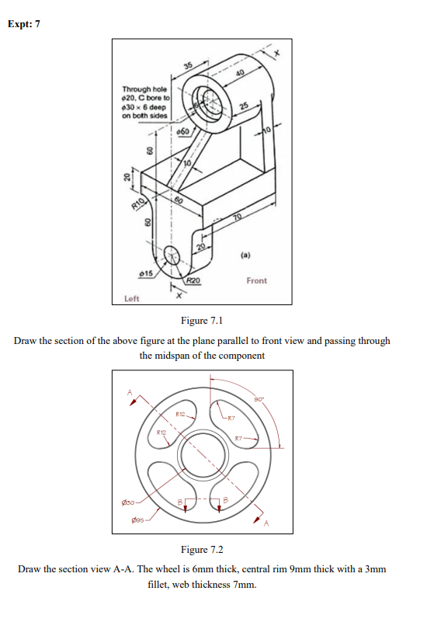

1. To create the 3D models of the given simple extrusion solids in AutoCAD. **(CO5)**

|  |  |  |
| --- | --- | --- |
| **S. No** | **Description** | **Marks** |
| 1 | Drawing | 5 |
| 2 | Dimension & Annotation | 5 |
| 3 | Layout | 5 |
| 4 | Printout | 5 |
|  | **Total** | 20 |

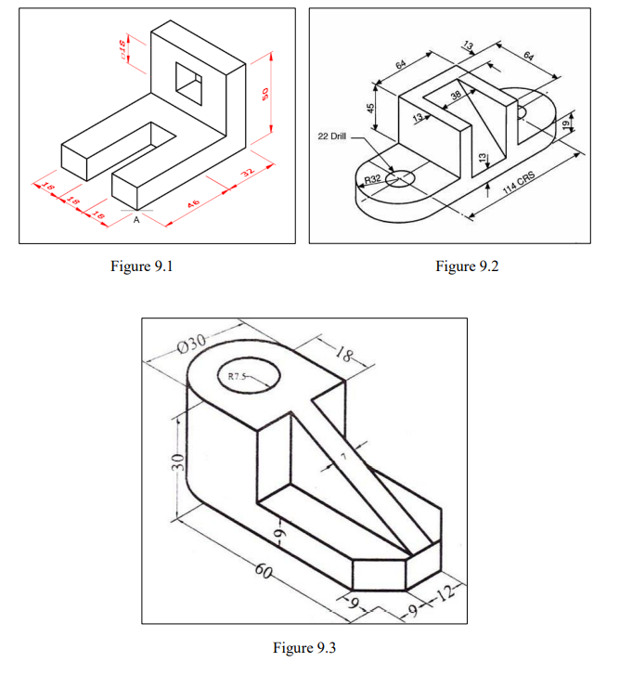

10 To create the 3D models of the given simple revolute solids in AutoCAD. **(CO5)**

|  |  |  |
| --- | --- | --- |
| **S. No** | **Description** | **Marks** |
| 1 | Drawing | 5 |
| 2 | Dimension & Annotation | 5 |
| 3 | Layout | 5 |
| 4 | Printout | 5 |
|  | **Total** | 20 |

